- Create an Instance of Application Insights
  - Screenshot showing the creation of an Application Insights instance in the Azure portal.
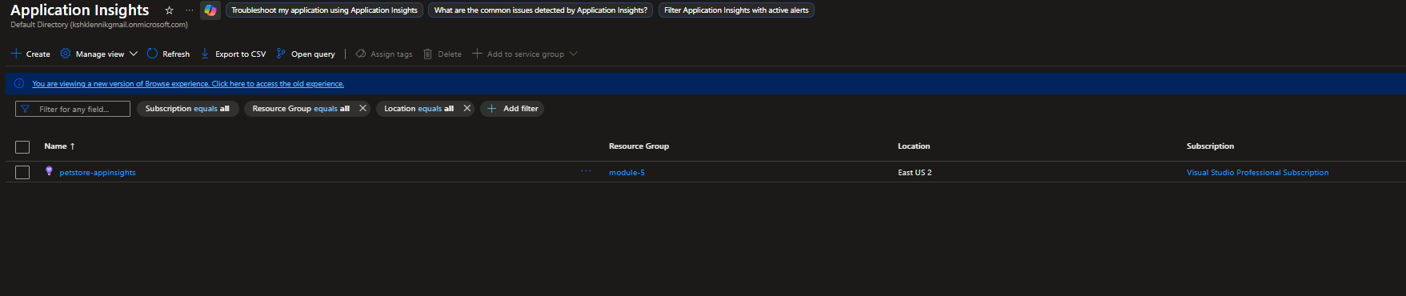
- Enable Connection to Application Insights
  - Screenshot demonstrating integration with Application Insights.
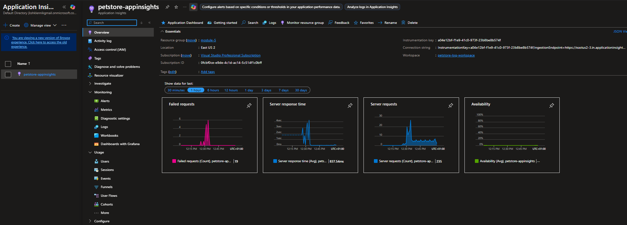
  - Screenshots of the deployed PetStore services with enabled Application Insights connections.
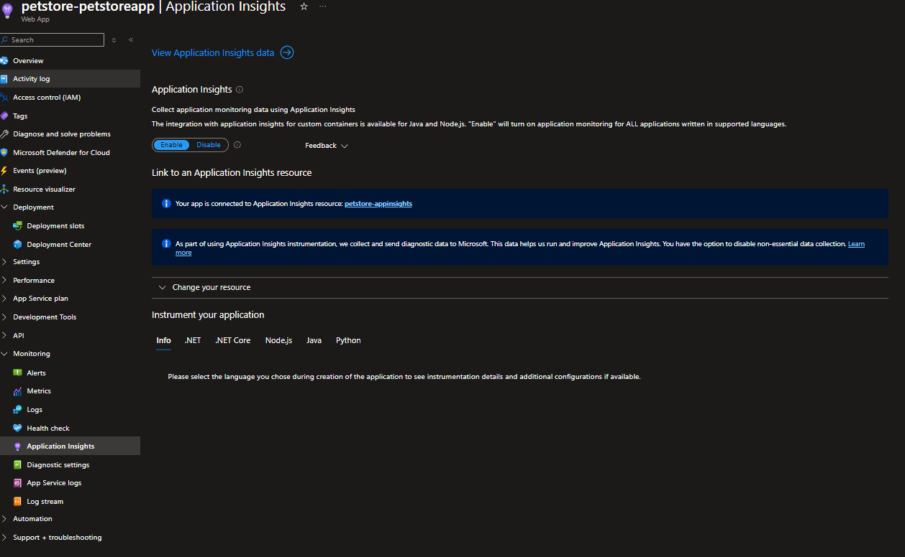
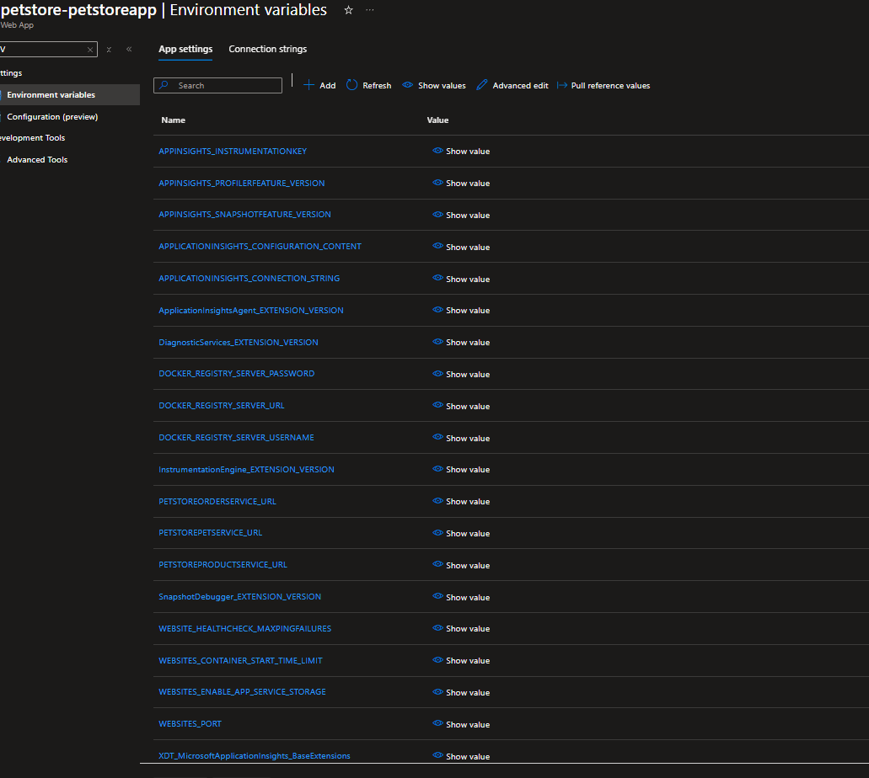
- Browse the Pet Store Website
  - Screenshots capturing the process of adding multiple products to the shopping cart on the Pet Store website.
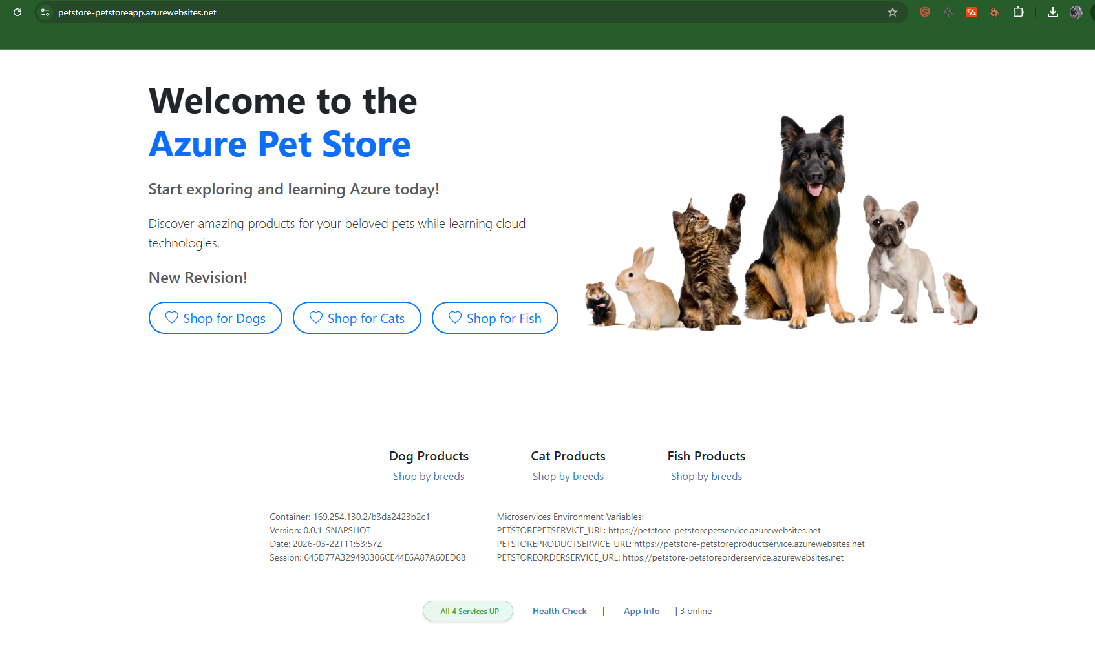
- Check Application Insights
  - Screenshots of the Application Insights dashboard:
    - Overview tab displaying incoming requests and failures.
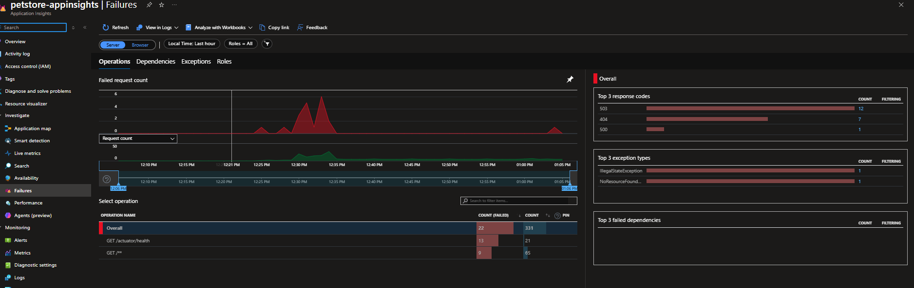
    - Live metrics tab displaying real-time metrics.
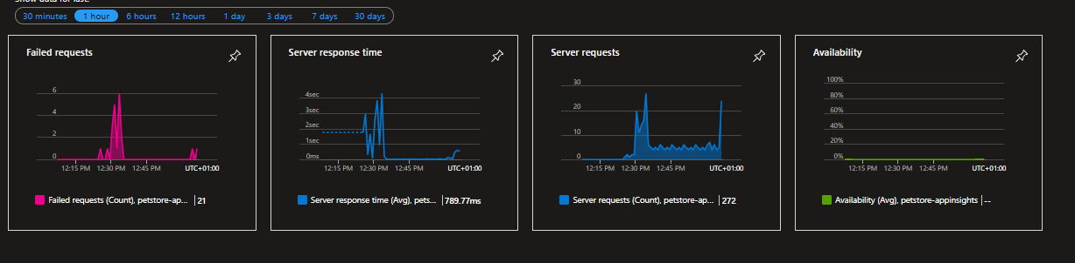
    - Transaction search results.
    - Performance metrics relevant to the PetStore services.
- Implement Changes in the Code
  - Screenshot of the added custom metric in com.chtrembl.petstoreapp.service.ProductManagementService#getProductsByCategory().
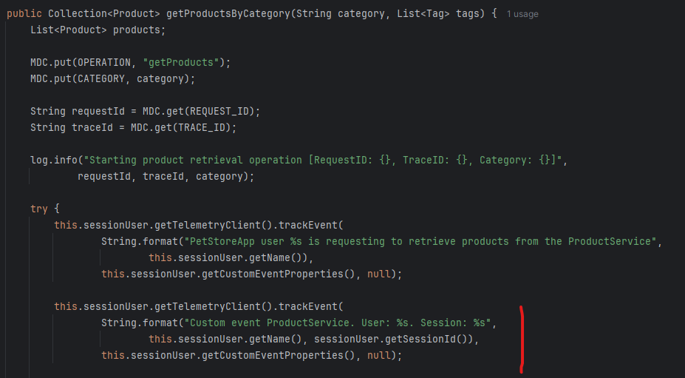
  - Screenshot showing added logging for the number of returned items.
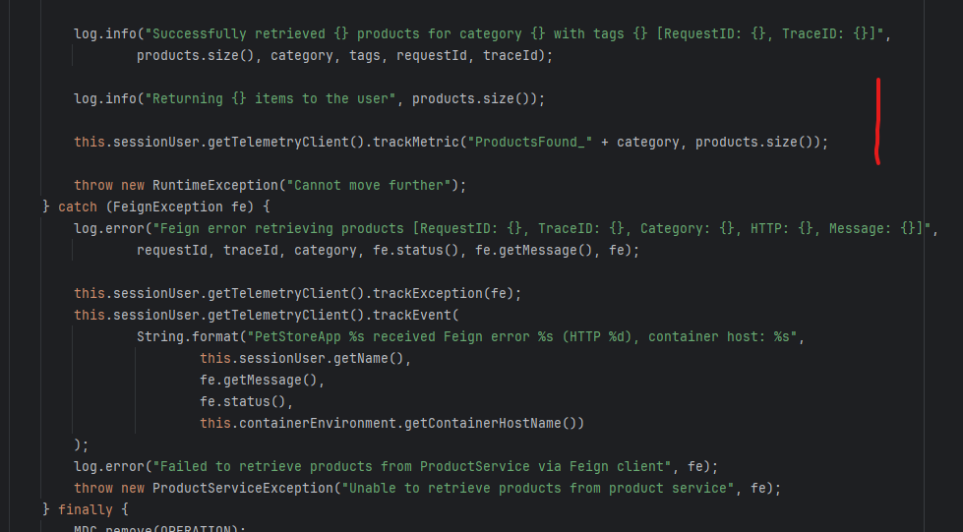
  - Screenshots of the deployed PetStore services with implemented code changes.
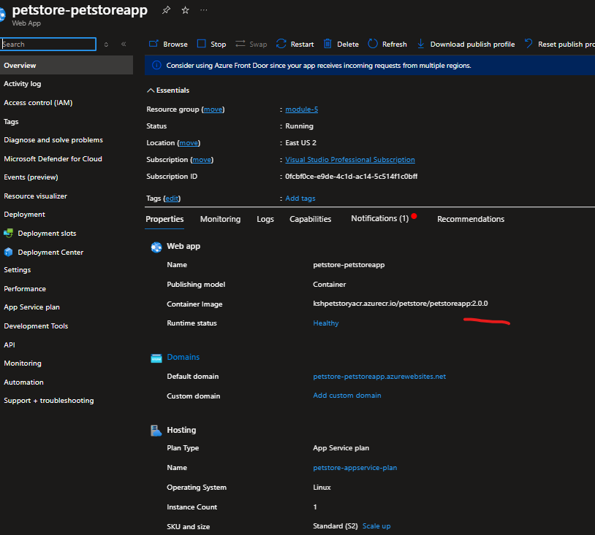
- Examine Logs and Custom Events
  - Screenshots of Application Insights displaying logged events and custom metrics.
- Use Kusto Query to Filter Logs
  - Screenshot of a Kusto query filtering logs by the current session ID.
- Introduce an Error in the Code
  - Screenshot of the code with the introduced error line.
- Redeploy Service and Check Logs
  - Screenshots of the deployed PetStore services with the introduced error.
  - Screenshots of Application Insights displaying logs related to the error.
- Use Kusto Query to Count Exceptions
- Screenshot of a Kusto query counting exceptions with specific error messages.
- Examine Error in Detail
- Screenshot of the "Failures" tab in Application Insights displaying the stack trace of the error.

